Shopping Cart Web Application

***Wireframe Documentation***

***Vishal Katkar***

Home Page

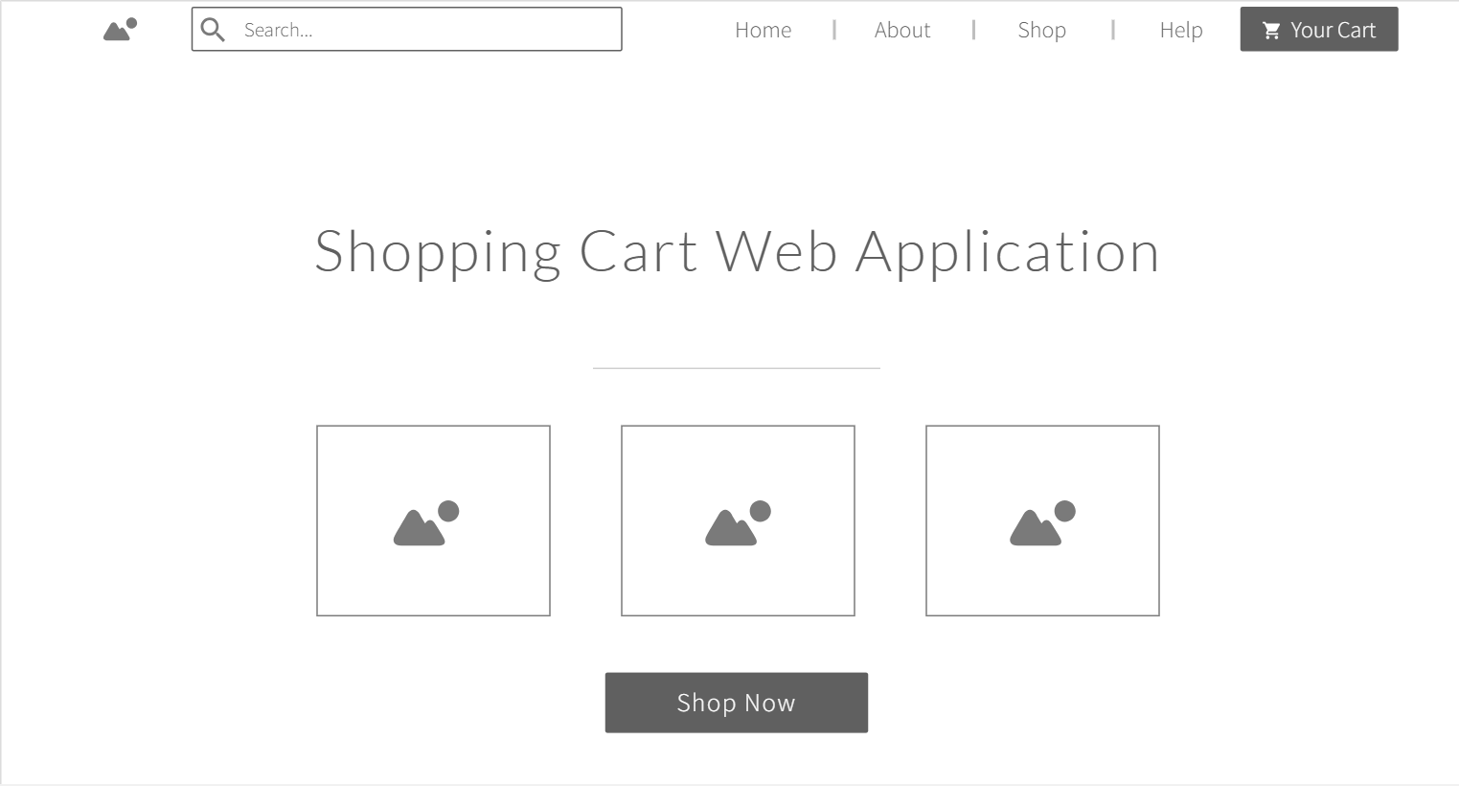

Product

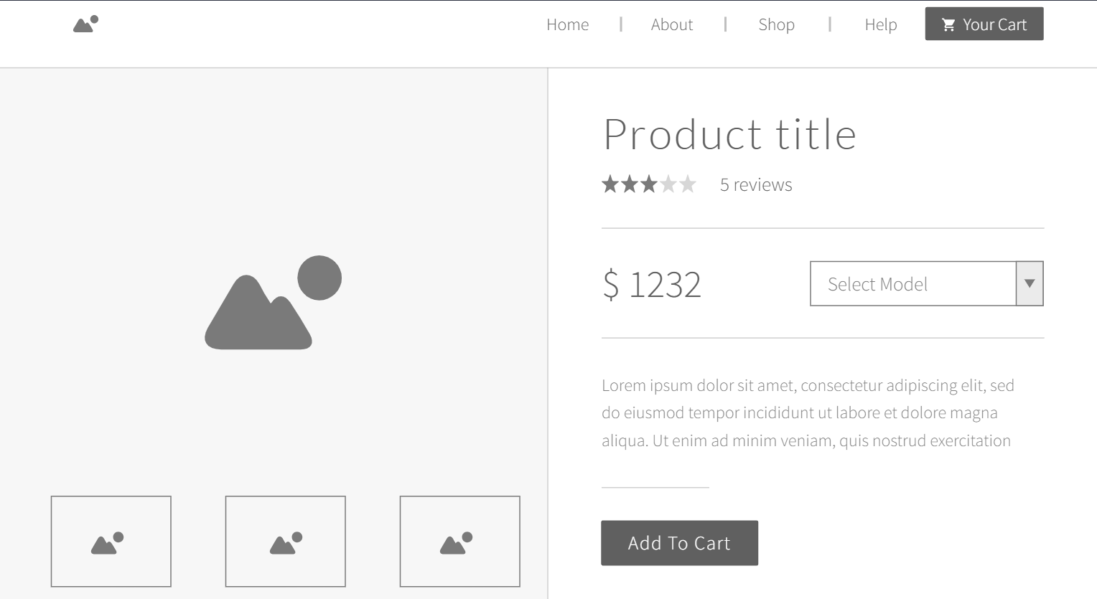

Cart

